Design Patterns
Design patterns play an important role in designing object oriented software. They represent „best practices“ in commonly occurring problems. The nature of Metamodeler allows to use Composite pattern because it lets you build complex diagrams out of simple components. This feature is important in Metamodelers graphical editor which allows users to create their models from many shapes and other objects. It also enables to group simple components into larger containers while preserving transparency, because you can treat all components uniformly.

Composite diagram
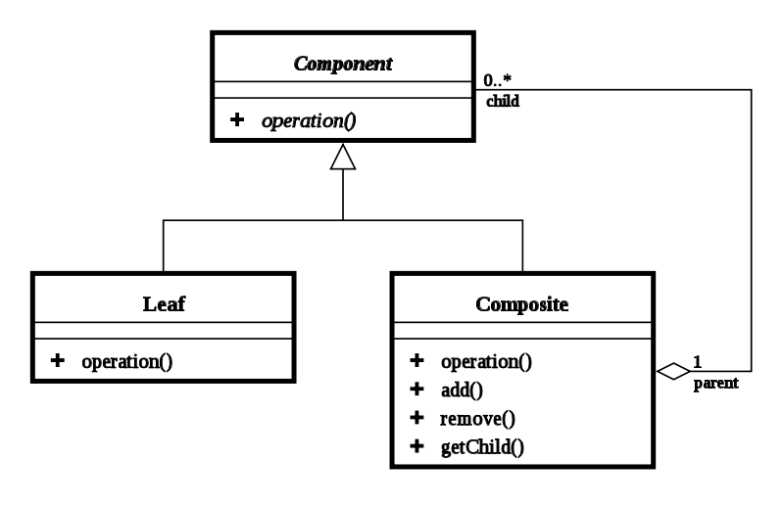
- Component – declares interface for all objects
- Leaf – represents leaf objects, has no children
- Composite – represents components having children
Composite pattern gave us scaling object structure, but implementing new functionality to this structure is quite difficult. That's why composite pattern is commonly used with Visitor. It allows to algorithm from object structure and thus add new operations without changing the classes on which they operate.

Visitor diagram
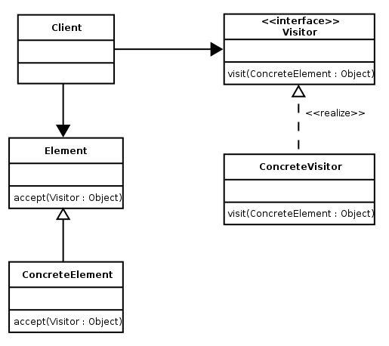
- Visitor – declares a Visit operation for each class of ConcreteElement
- ConcreteVisitor – implements fragment of the algorithm defined for corresponding ConcreteElement
- Element – defines Accept operation
- ConcreteElement – implements an Accept operation

And finally when using sort of object structure it's helpful to have a method to sequentially access all elements without exposing underlying structure. And the pattern is called Iterator. Basic methods provide sequential access to elements and a test whether it's end. Those methods usually are next() and hasNext().

Source:
GAMMA, Erich, et al. Design patterns : elements of reusable object-oriented software. [s.l.] : [s.n.], 1995. 395 s. ISBN 9780201633610.

